Cloud Advisor

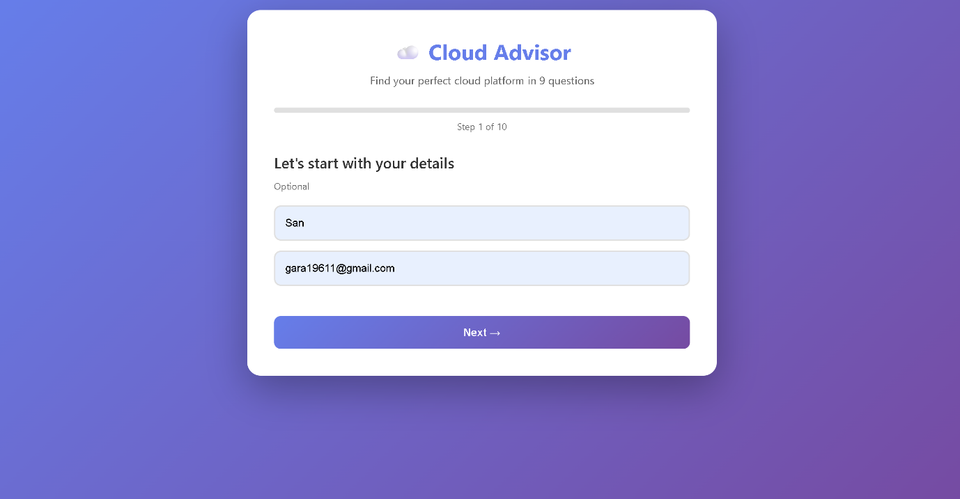

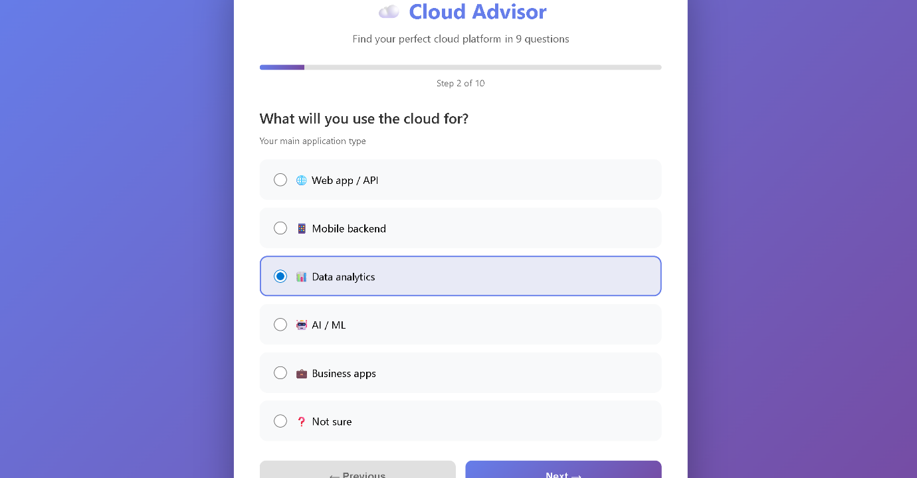

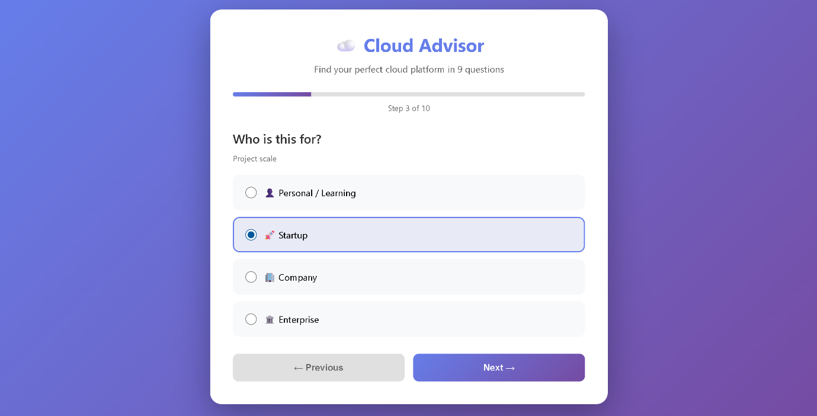

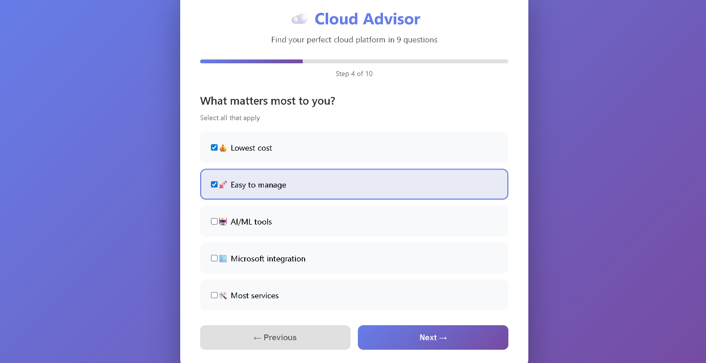

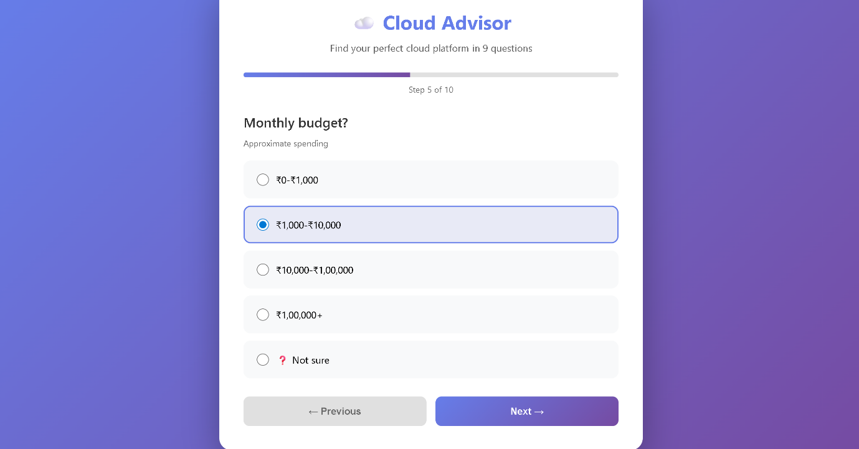

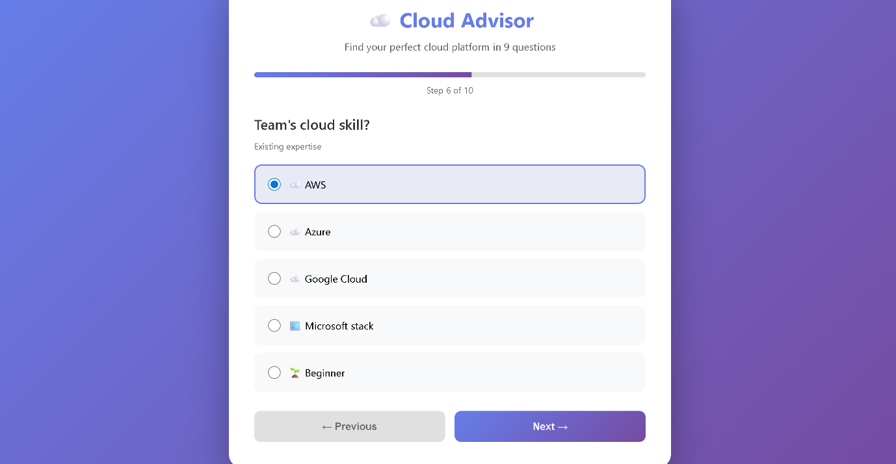

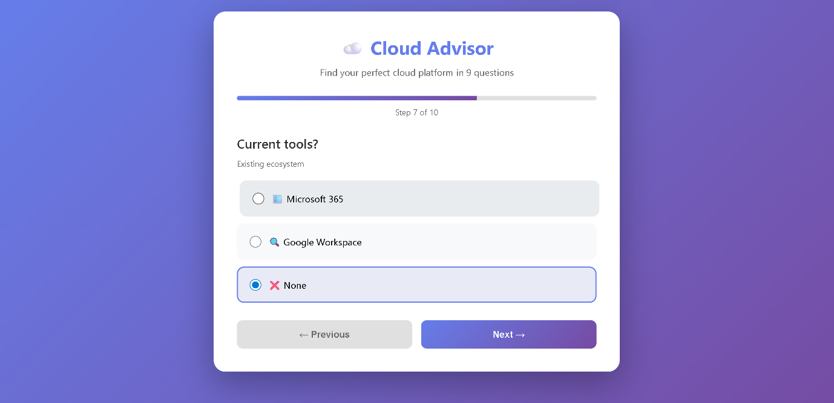

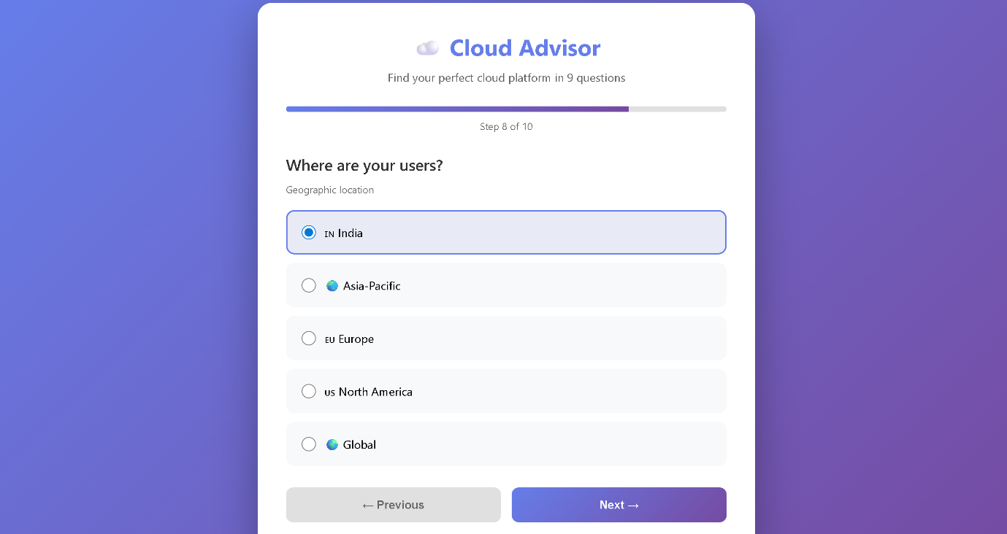

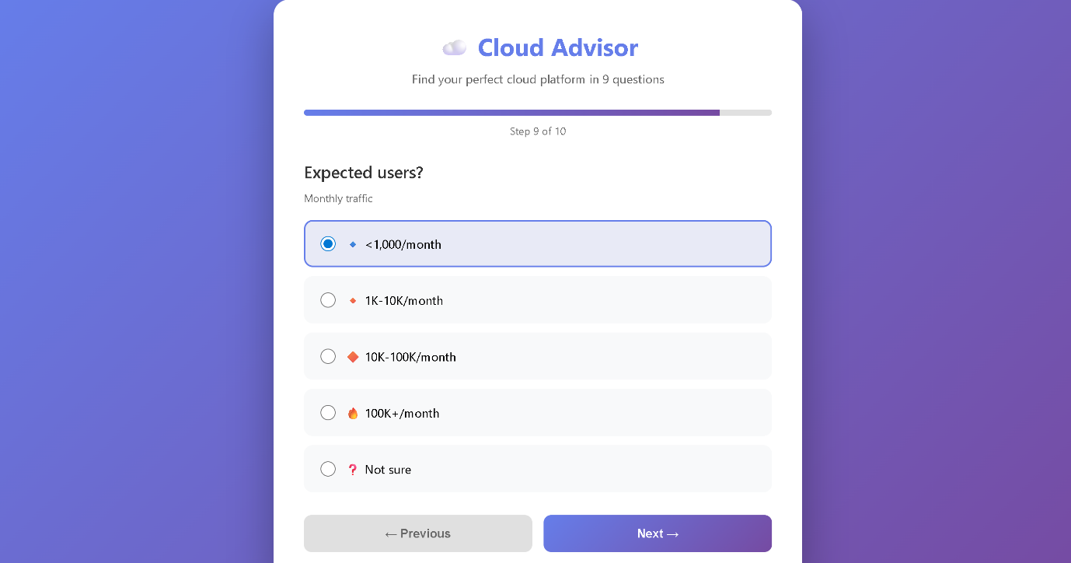

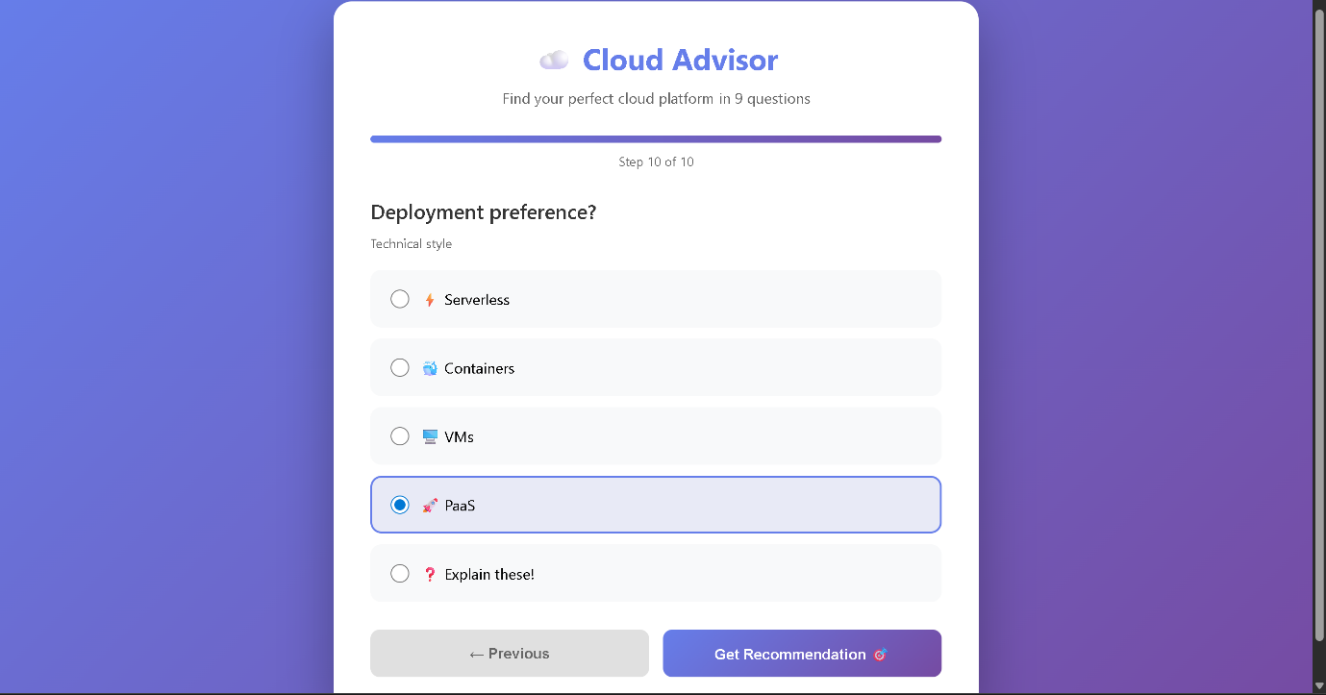

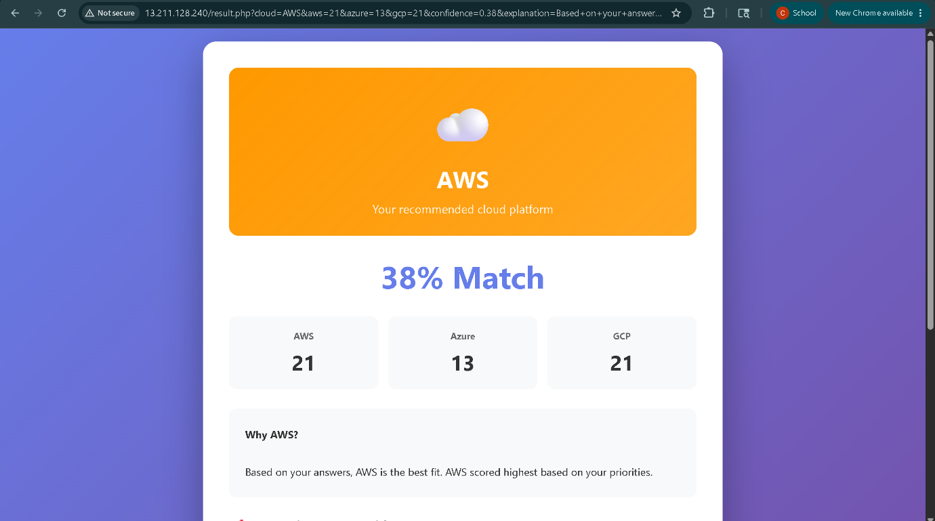

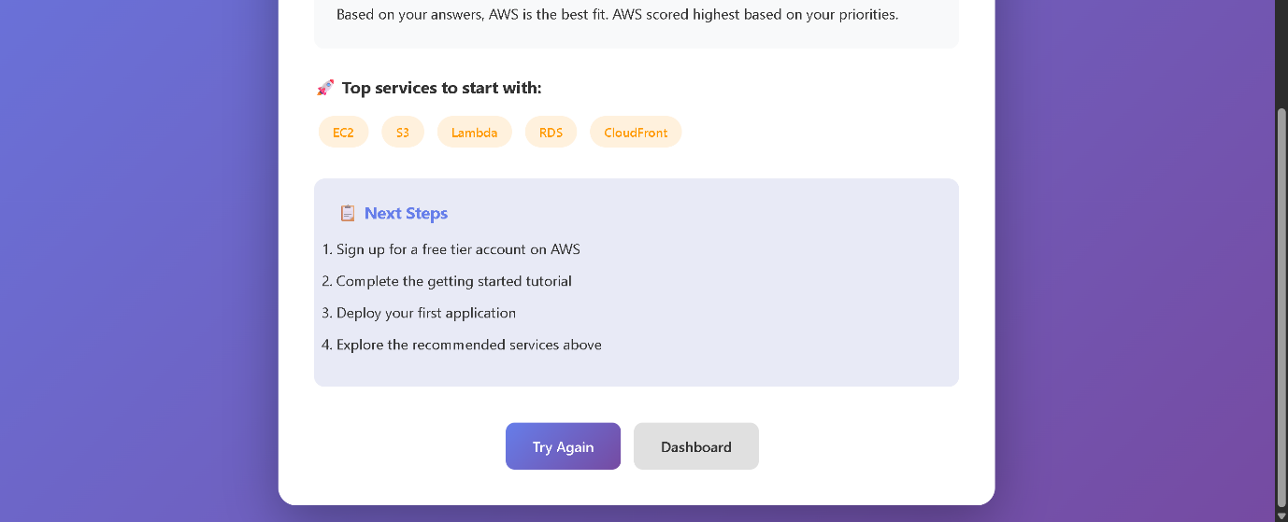

1.Created the Cloud Advisor Quiz System
- User details (name, email)
- Use case selection (web app, mobile backend, AI/ML, etc.)
- Project scale (personal, small business, enterprise)
- Priorities (cost, ease of use, AI tools, Microsoft integration, services)
- Technical preferences (experience level, existing cloud usage)
- Workload patterns, compliance needs, support requirements
- Budget range

2.Built the Recommendation Engine
Created scoring algorithm in process-recommendation.php:
- AWS, Azure, and GCP get points based on user answers
- Highest score = recommended cloud provider
- Generates personalized explanation of why that provider was chose

3.Set up MySQL Database
- Created cloud_recommendations table to store:
- User responses
- Scores for each cloud provider
- Final recommendation
- Confidence score
- Timestamp
4. Created Results Page
Built result.php that displays:
- Recommended cloud provider with logo
- Confidence score
- Detailed explanation
- Score comparison (AWS vs Azure vs GCP)
- "Start Over" button

5. Made UI
- Emoji icons for visual appeal

How the PHP Scoring Algorithm Works
Step 1: Initialize Scores
For aws,azure,gcp
Step 2: Collect User Input
Get points of usecasess,priority,budget
If in Use Case Scoring
User choose web-development we shall assign aws+3 points, azure+3 and gcp+2 points
- If budget is less than $100/month, GCP gets 3 points (cheapest option)
- If budget is over $2000/month, AWS and Azure get 4 points (enterprise-ready)
So how we allocate this:
Provider | Score | Reasoning
AWS | +3 | AWS has EC2, Lambda, API Gateway - very popular for web apps
Azure | +3 | Azure has App Service, Functions - equally good for web apps
GCP | +2 | GCP has App Engine, Cloud Run - good, but less popular for traditional web apps

These are real world scenarios.

Similarly for aiml:
Provider | Score | Reasoning
GCP | +5 | Google invented TensorFlow! Has Vertex AI, AutoML, TPUs - industry leader
AWS | +3 | Has SageMaker, good ML tools, but not as cutting-edge as GCP
Azure | +3 | Has Azure ML, decent AI services, but behind Google

Like this for each use case,for each priorites the value changes and applies.

The Scale
Score | Meaning
+5 | Dominant - This provider is the clear best choice
+3-4 | Strong - Very good option
+2 | Average - Decent option
+1 | Weak - Not ideal
+0 | Not relevant - Doesn't apply

How Calculation works:
Your EC2 server (the backend) calculates it using PHP
User Fills Out the Form
The form data is sent via HTTP POST to process-recommendation.php.
The PHP interpreter on EC2 server executes the code
The scores and recommendation are stored in MySQL
PHP redirects the user to result.php
The browser displays the results that were already calculated on the server.

How User Clicks Connect to Scoring
When user clicks:
- Browser marks this radio button as selected
- Value datanalaytics is stored temporarily in the form
- NO calculation happens yet! Just storing the choice.
So no calc till recommendation
Clicking recommendation-triggers the data transfer
PHP executes line-by-line and calculates the scores
Why We Chose PHP-PHP is a server-side programming language used to build dynamic websites and web applications.
1. Server-Side Logic
We need to calculate scores on the server (not in browser)
PHP runs on the server and processes data securely
JavaScript (browser) can be manipulated by users - PHP can't!
2. Database Integration
PHP has built-in MySQL support (mysqli, PDO)
Easy to save/retrieve data from database
3. Easy to Learn & Deploy and widely supported
PHP is beginner-friendly
Works with Apache web server (already on your EC2)
No complex setup needed - just upload .php files!
- Server-side security
- Built-in MySQL support

